**Programming Assignment: Mountain Paths**

In this lab you will read a set of topographic (land elevation) data into a 2D array and write some methods to compute some paths through the mountains as well as visualize them.

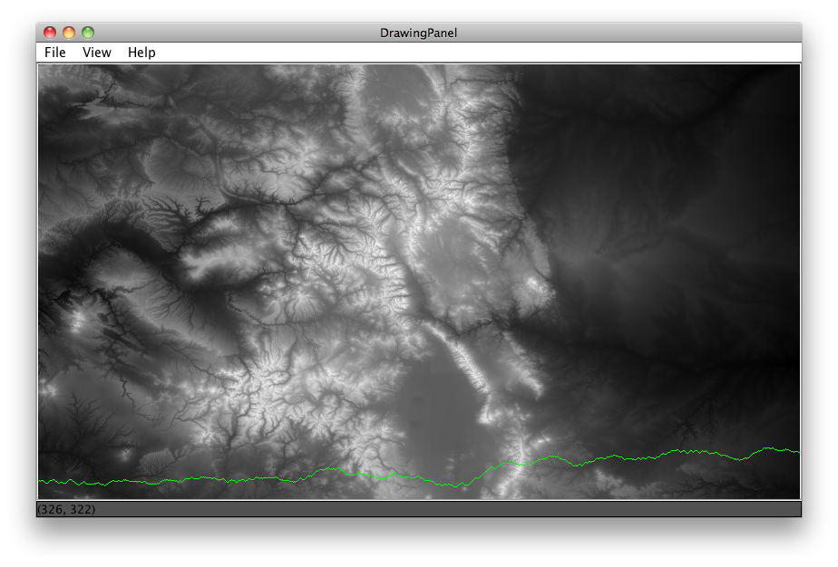**Background**:

There are many contexts in which you want to know the most efficient way to travel over land. When traveling through mountains (let's say you're walking) perhaps you want to take the route that requires the least total change in elevation with each step you take – call it the path of least resistance. Given some topographic data it should be possible to calculate a "greedy lowest-elevation-change walk" from one side of a map to the other.

In the map above, brighter shades mean higher elevation. The green line shows a lowest-elevation-change route for this map, traveling west-to-east.

**A Greedy Walk**

A "greedy" algorithm is one in which, in the face of too many possible choices, you make a choice that seems best at that moment. For the maps we are dealing with there are 7.24x10405 possible paths you could take starting from western side of the map and taking one step forward until you reach the eastern side.

Since our map is in a 2D grid, we can envision a "walk" as starting in some in some cell at the left-most edge of the map (column 0) and proceeding forward by taking a "step" into one of the 3 adjacent cells in the next column over (column 1). Our "greedy walk" will assume that you will choose the cell whose elevation is closest to the elevation of the cell you're standing in. (NOTE: this might mean walking uphill or downhill).

Shows a portion of the data. Greedy path shown in green.

The diagrams below show a few scenarios for choosing where to take the next step. In the case of a tie with the forward position, you should always choose to go straight forward. In the case of a tie between the two non-forward locations, you should flip a coin to choose where to go.



Case 4: smallest change is a tie (4), choose randomly between fwd-up or fwd-down

Case 3: smallest change is a tie (3), fwd is an option, so go fwd

Case 2: smallest change is 3, go fwd

Case 1: smallest change is 5, go fwd-down

There are other ways to choose a path through the mountains that can be explored in the "above and beyond" section of this assignment.

**Assignment Requirements**

The minimum requirements for the assignment are that you write code to produce something like the map shown in the picture above. To do that you need to complete the following 5 steps:

Step 1: Read the data into a 2D array

Step 2: Find min, max elevations, and other calculations on the data

Step 3: Draw the map

Step 4: Draw a lowest-elevation-change route starting from some row

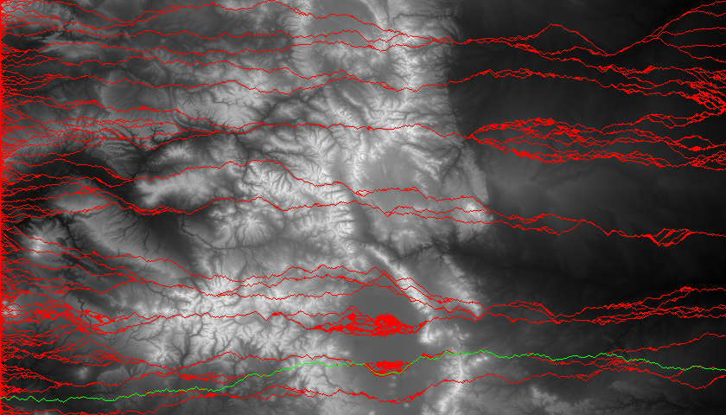Step 5: Find and draw the lowest-elevation-change route in the map